* 1. *Design of Power supply:*

All electronic circuits use DC power supply of adequate voltage for their operation.

To obtain this DC voltage from 230V AC mains, we need to use a ‘rectifier’. The rectified DC voltage is ‘pulsating ’ in nature. We know that a combination of rectifier & filter can produce a dc voltage which is almost pure i.e. ripple free.

However, the problem with such a power supply is that its output voltage will not remain constant in the event of fluctuations in ac input voltage or changes in load current. This type of power supply is called as unregulated power supply.

The power supply, which provides a constant output voltage irrespective of everything is called, regulated power supply. So we have to design a regulated power supply using series voltage regulator IC 7805.

Following figure shows general block diagram of regulated power supply.

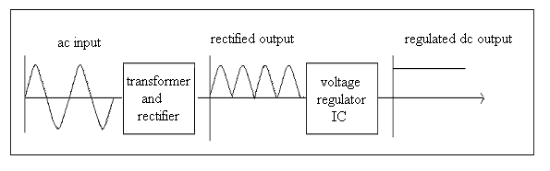

**FIGURE 8: GENERAL BLOCK DIAGRAM OF POWER SUPPLY**

**BRIDGE RECTIFIER**

Bridge rectifier circuit consists of four diodes arranged in the form of a bridge as shown in figure.

A 1

D1 D3

AC Supply

3 Load 4

+

D4 D2

B 2

Figure No. 1.11: Bridge Rectifier

**OPERATION**

During the positive half cycle of the input supply, the upper end A of the transformer secondary becomes positive with respect to its lower point B. This makes Point1 of bridge

Positive with respect to point 2. The diode D1 & D2 become forward biased & D3 & D4 become reverse biased. As a result a current starts flowing from point1, through D1 the load & D2 to the negative end.

During negative half cycle, the point2 becomes positive with respect to point1. Diodes

D1 & D2 now become reverse biased. Thus a current flow from point 2 to point1.

**7) TRANSFORMER**

Transformer is a major class of coils having two or more windings usually wrapped around a common core made from laminated iron sheets. It has two cols named primary and secondary. If the current flowing through primary is fluctuating, then a current will be inducted into the secondary winding. A steady current will not be transferred from one coil to other coil.

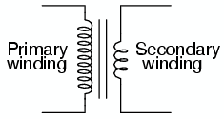

Figure No. 1.12: Basic Transformer

Design of C1:

The maximum current that can be drawn from this IC is 1A.

But our circuit requires maximum current of Imax, which is summation of all the current required to drive individual IC,s.

Im = 100 mA

For safety purpose, we consider the maximum current limit exactly double of the circuit requirement

Imax=2Im.

Therefore, Imax = 200 mA.

We know that,

Q = CV ……………………………….. (1)

Where,

Q = charge on capacitor.

C = capacitance.

V = voltage applied to capacitor.

Also,

Q = I t. ……………………………….. (2)

Where,

I = Imax.

t = period of output voltage of rectifier.

Equating equations (1) & (2), we get

CV = Imax t. ……………………………….. (3)

Now, at input of transformer, applied voltage frequency is 50 Hz.

As we have used step down transformer of 9-0-9 V, we get output voltage having same frequency of 50 Hz but amplitude step down to 9V (rms).

After rectification, frequency doubles & amplitude becomes Vpeak, as shown in figure.

Vin(rms) = 230 v.

Vsec(rms)= 9v.

Therefore, Vpeak = Vp = Vsec / 0.707.

Vp = 12 v.

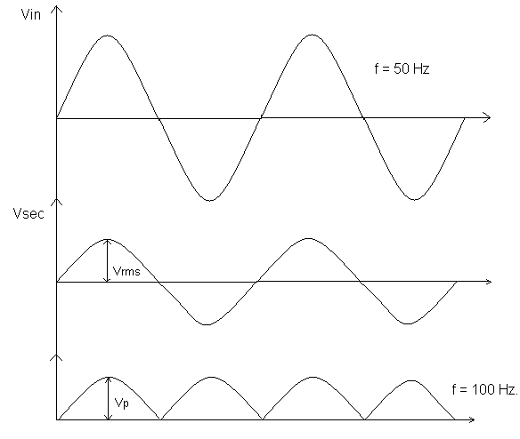

And, t = 1 / 2f.

= 1 / 100.

= 0.01 sec.

From equation (3),

CV = I t.

Therefore,

C = Imax t / V.

= 200 * 0.01 / 12

= 166.66 uF.

Select, C1= 470 uF.

Design of C2:

We know that, due to internal circuitry of IC 7805 and load connected at the output of power supply; various types of noises are generated at its output, such as thermal noise, flicker noise, shot noise, white noise etc. Hence in order to bypass all these noises, we have to connect a capacitor C2.

It can take value between 0.1uF to 100uF.

Here we have connected C2 = 100 uF.

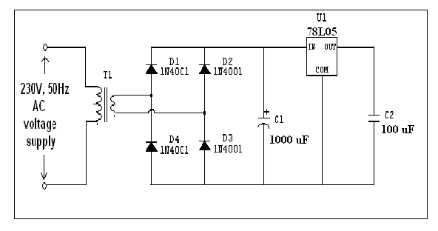

**FIGURE 9: DESIGN FOR 5v POWER SUPPLY**

**LCD DISPLAY**

**DESCRIPTION OF LCD DISPLAY**

This is the first interfacing example for the Parallel Port. We will start with something simple. This example doesn't use the Bi-directional feature found on newer ports, thus it should work with most, if not all Parallel Ports. It however doesn't show the use of the Status Port as an input. These LCD Modules are very common these days, and are quite simple to work with, as all the logic required to run them is on board.

**SCHEMATIC DIAGRAM**

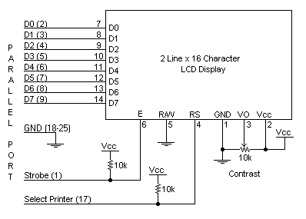

Figure No. 1.8: Schematic Diagram of LCD Display

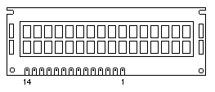

Figure No. 1.9: LCD Display